<https://www.ni.com/en/shop/labview/pid-theory-explained.html?srsltid=AfmBOooe6UB5c72GAOhPRzVQ-tHpZipfVcLoDEcytbATgDVb-HcdMvC0>

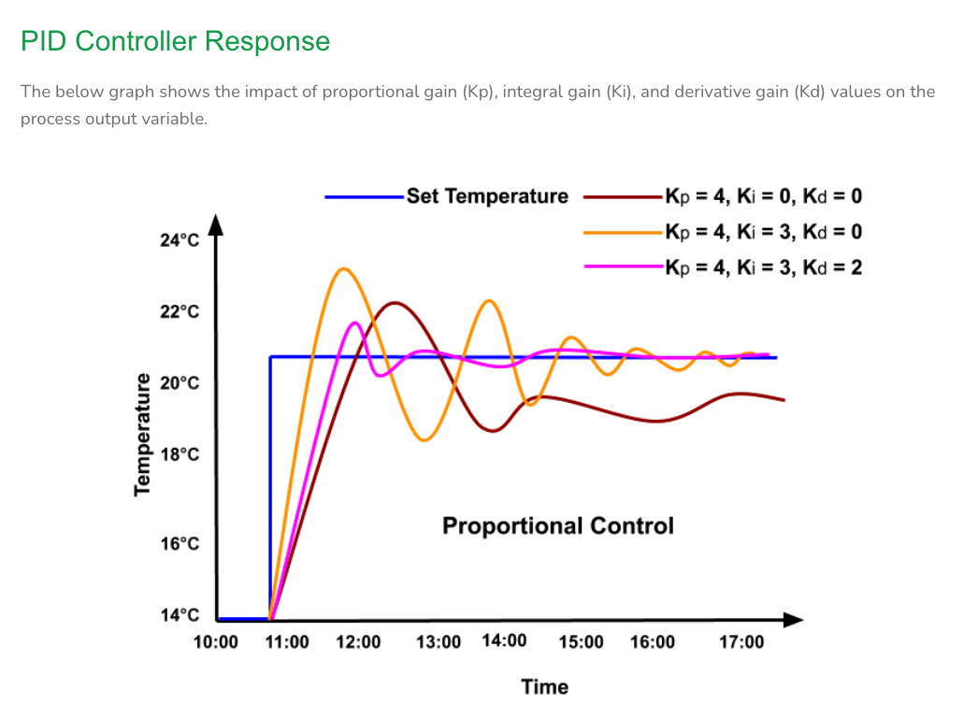

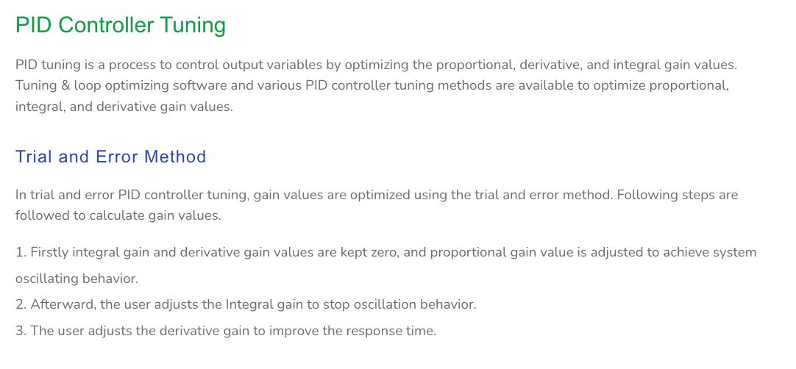

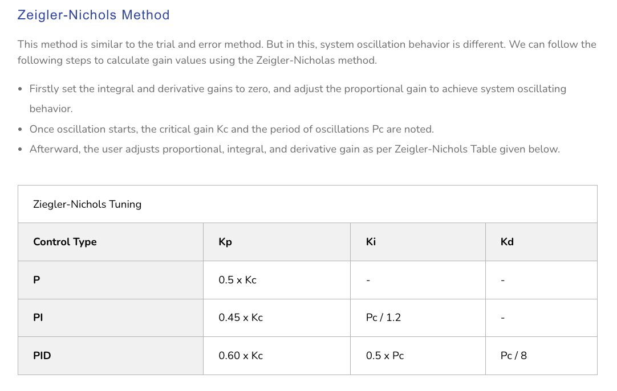

The derivative term, D, in a PID controller is a calculation that assesses how quickly an error is changing. It's one of three terms in a PID controller, along with the proportional and integral terms. Basically, the bigger D (bigger error/ difference between the current and previous error) cause bigger OUTPUT that make the controller move quicker to the setpoint.

How it works

* The derivative term is calculated by dividing the difference between the current and previous error values by the time between measurements.
* The derivative term is multiplied by a constant, Kd, and then added to the total output.
* A properly tuned derivative term can reduce oscillations in the controller.

When it's useful

* The derivative term is useful for systems that experience sudden changes, such as quadcopters.
* It can also help prevent strong overshoot and decrease oscillations.

When it's not useful

* The derivative term can amplify measurement noise and external disturbances.
* It can be impractical for many industrial applications.
* Large derivative action can destabilize a loop.